EXPT NO: 8 | TRAIN A SIMPLE AUTOENCODER FOR DIMENSIONALITY REDUCTION AND FEATURE LEARNING
DATE:

PRE-LAB QUESTIONS (PROVIDE BRIEF ANSWERS TO THE FOLLOWING QUESTIONS

1. What is an Autoencoder?

An Autoencoder is an artificial neural network used to compress data and reconstruct the original data.
It learns important features from the input data and tries to reproduce the same input at the output.
Example: Compressing an image and reconstructing the original image.
2. What are the roles of the Encoder and Decoder in an Autoencoder?
An autoencoder has two main parts:
- Encoder: Converts the input data into a smaller, compressed representation by extracting important features.
- Decoder: Reconstructs the original data from the compressed representation.
Example: Encoder compresses an image, and Decoder recreates the image.
3. What is Dimensionality Reduction?
Dimensionality reduction is the process of reducing the number of features or variables in a dataset while keeping the important information.
Example: Reducing 100 input features into 10 important features.
Purpose: It reduces complexity, saves storage and improves processing speed.
4. What is meant by Latent Representation or Latent Space?
Latent representation is the compressed form of input data that contains its important features.
Latent space is the smaller space where this compressed information is stored.
Example: An image is converted into a small set of important numerical values.
5. Why is Reconstruction Loss used when training an Autoencoder?
Reconstruction loss measures the difference between the original input and the reconstructed output.
It helps the autoencoder learn to reproduce the original data as accurately as possible.
Example: If the original image and reconstructed image are different, reconstruction loss measures that difference.
Purpose: To minimize errors and improve reconstruction accuracy.

AIM
To implement and train a simple autoencoder using a dataset such as MNIST, learn a lower-dimensional representation of the input data, and evaluate the model by reconstructing the input samples and visualizing their latent representations.
SOFTWARE REQUIREMENTS
- Python
- TensorFlow / Keras
- Google Colab or Jupyter Notebook
- GitHub
- NumPy
- Matplotlib
- Pandas (optional)

OBJECTIVES
Students will be able to:
- Understand the architecture and working of autoencoders.
- Differentiate between the encoder, latent representation, and decoder.
- Prepare and preprocess a dataset for autoencoder training.
- Build an autoencoder using appropriate neural network layers.
- Train the model using reconstruction loss.
- Perform dimensionality reduction and extract latent features.
- Visualize original and reconstructed samples.
- Evaluate reconstruction performance using loss values and visual inspection.
PROCEDURE
PART A: DATASET PREPARATION AND PREPROCESSING
Perform the following tasks:
- Load the MNIST handwritten digit dataset using TensorFlow/Keras.
- Explore the dataset and check the number of training and testing images and their dimensions.
- Display sample images from the dataset.
- Convert pixel values to floating-point values and normalize them to the range [0, 1].
- Flatten each 28 × 28 image into a 784-dimensional input vector for a basic dense autoencoder.
- Prepare training and testing data. Use the input images as both input and target output because the autoencoder learns to reconstruct its input.

CODE:
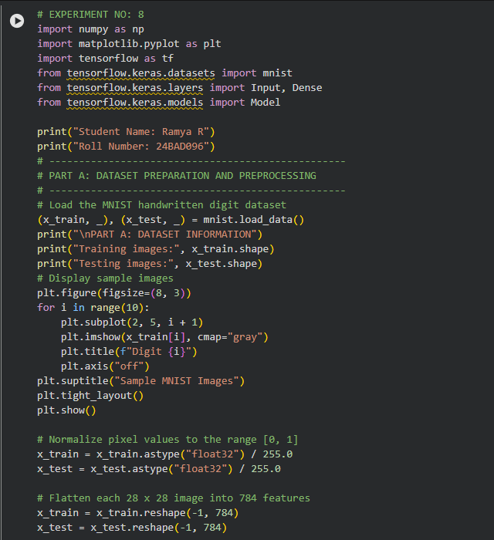
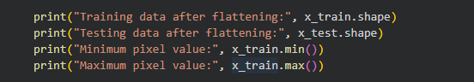
OUTPUT:
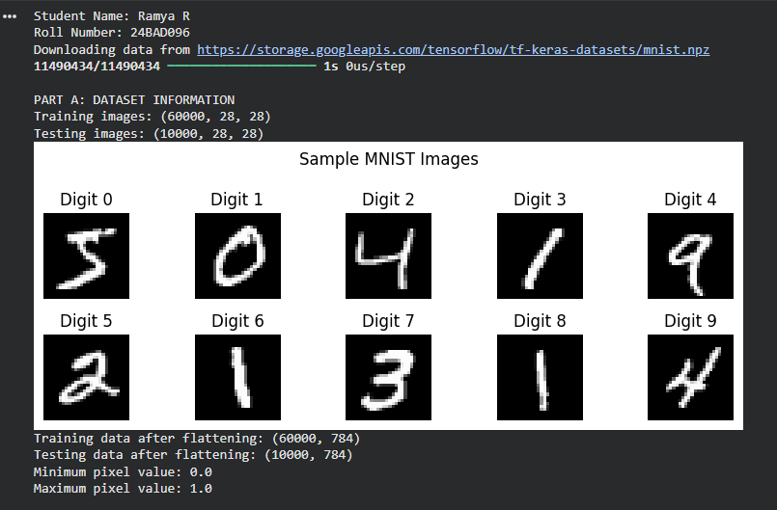
PART B: IMPLEMENTING THE ENCODER AND DECODER
Perform the following tasks:
- Define the input layer with 784 features.
- Build the encoder using one or more Dense layers to map the input to a smaller latent dimension, such as 32 features.
- Build the decoder using Dense layers to map the latent representation back to 784 output values.
- Use suitable activation functions, such as ReLU for hidden layers and Sigmoid for the final layer.
- Combine the encoder and decoder into a single autoencoder model.
- Display the encoder, decoder, and autoencoder model summaries.

CODE:
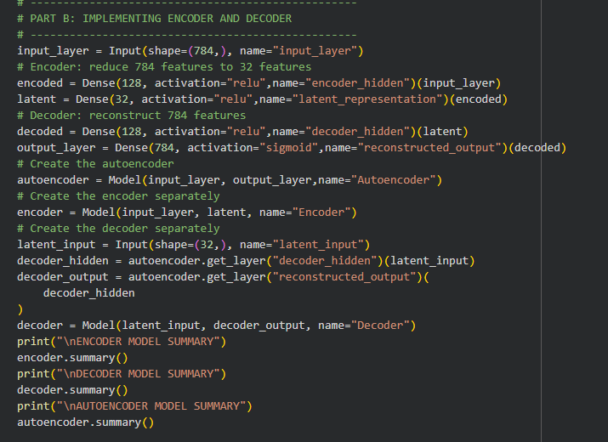
OUTPUT:
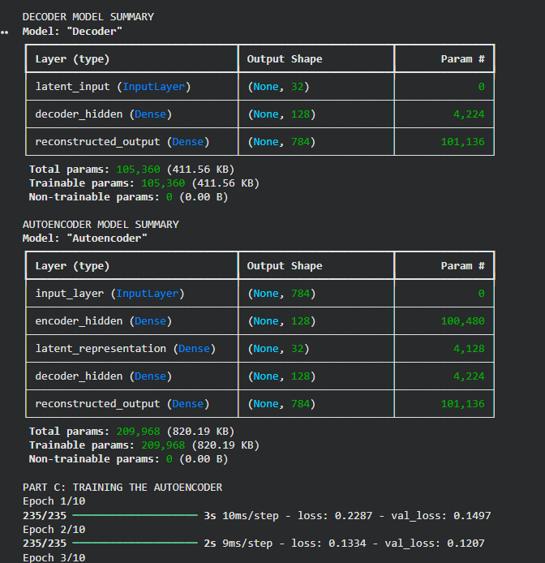

PART C: COMPILING AND TRAINING THE AUTOENCODER
Perform the following tasks:
- Compile the autoencoder using an optimizer such as Adam.
- Select an appropriate reconstruction loss, such as binary cross-entropy or mean squared error.
- Train the model by supplying the input images as both input data and target data.
- Use a suitable batch size and number of epochs. For example, use a batch size of 256 and 10 epochs.
- Validate the model using the test dataset or a validation split.
- Record training and validation loss for each epoch.
- Plot the training and validation loss curves to observe the reconstruction performance.
CODE:
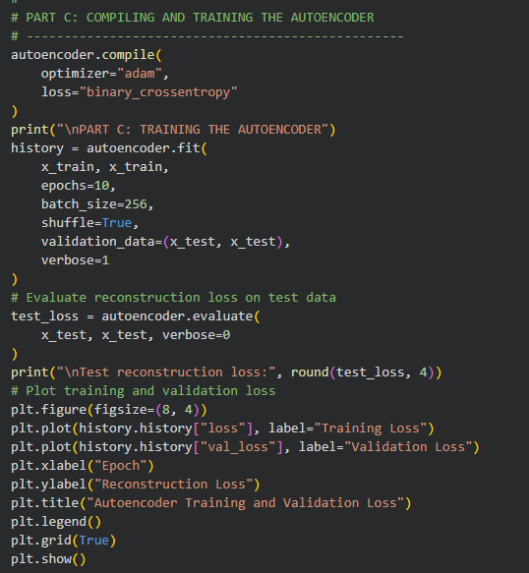
OUTPUT:
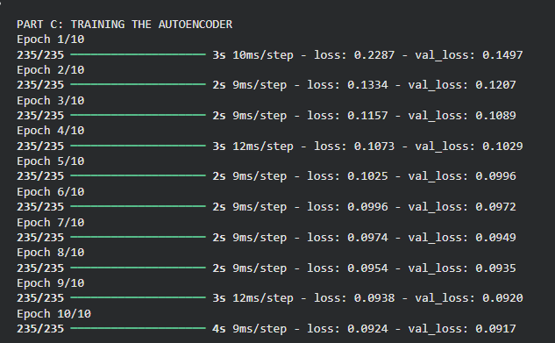
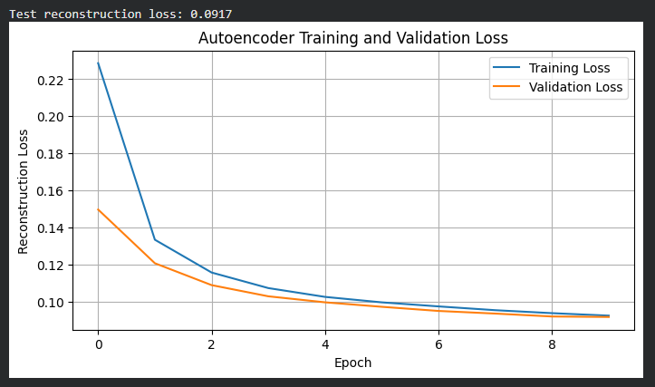

PART D: DIMENSIONALITY REDUCTION, FEATURE LEARNING AND RECONSTRUCTION
Perform the following tasks:
- Use the trained encoder to convert test images into lower-dimensional latent feature vectors.
- Display the original input dimension (784) and latent dimension (for example, 32).
- Pass the latent vectors through the decoder to reconstruct the images.
- Display original images and their corresponding reconstructed images side by side.
- Compare the original and reconstructed images and comment on the information retained or lost.
- Optionally, use PCA or t-SNE to visualize latent features in two dimensions, if covered in the course.
- Save the trained model or reconstructed images if required.

CODE:
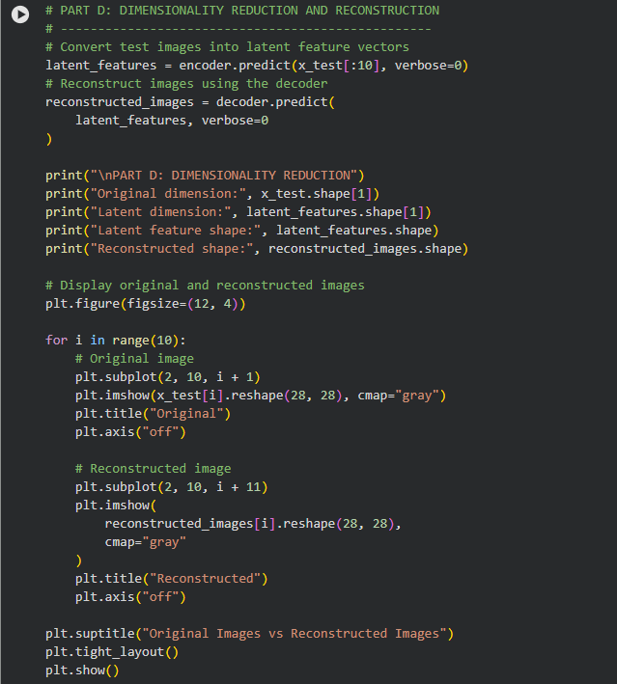
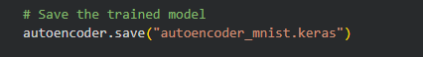
OUTPUT:
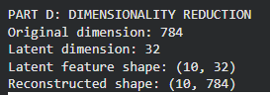
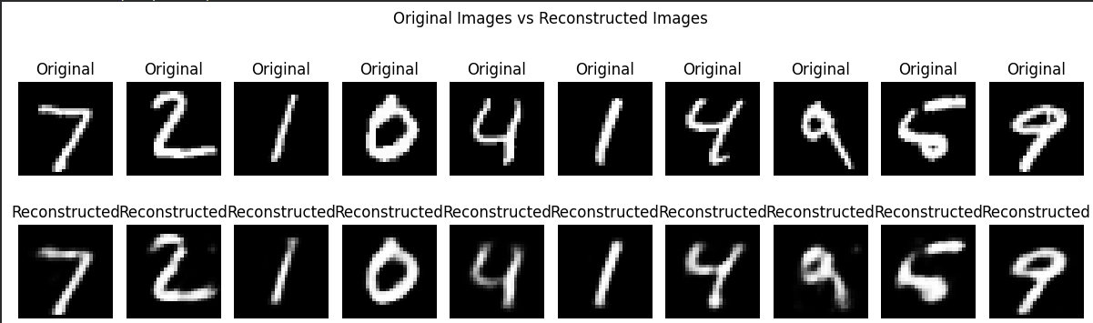

EXPECTED OUTCOME
Students will understand the architecture and working of a simple autoencoder and the roles of its encoder, latent representation, and decoder. They will learn to preprocess data, train the model using reconstruction loss, reduce input dimensionality, and extract compact latent features. They will evaluate the autoencoder by examining training and validation loss and comparing original images with reconstructed images.

POST-LAB QUESTIONS (PROVIDE BRIEF ANSWERS TO THE FOLLOWING QUESTIONS)

1. What is the main purpose of an autoencoder?
An autoencoder is a neural network used to compress data.
It learns important features from the input data.
It reconstructs the original data with minimum error.
2. How do the encoder and decoder differ?
The encoder compresses the input data into a smaller representation.
The decoder takes the compressed data as input.
It reconstructs the original data.
3. What is a latent representation?
Latent representation is the compressed form of input data.
It contains the most important features.
It is stored in a smaller-dimensional space called latent space.
4. How does an autoencoder perform dimensionality reduction?
An autoencoder reduces the number of input features.
The encoder converts input data into a smaller representation.
Important information is preserved in the compressed data.
5. Why are the input images also used as target outputs during training?
Autoencoders learn to reproduce the original input images.
The input image is given to the encoder and decoder.
The reconstructed image is compared with the original image.
6. What does reconstruction loss measure?
Reconstruction loss measures the difference between input and output data.
It identifies how much information is lost during reconstruction.
The model tries to minimize this loss during training.
7. What may happen if the latent dimension is too small?
The model may lose important information.
It cannot store all the necessary features.
As a result, the reconstructed output may have poor quality.
8. Mention one real-world application of autoencoders.
Autoencoders are used in image denoising.
They remove unwanted noise from images.
They help produce clearer and better-quality images.

SUGGESTIONS FOR DATASETS
- MNIST Handwritten Digits – https://www.tensorflow.org/datasets/catalog/mnist
- Fashion-MNIST – https://www.tensorflow.org/datasets/catalog/fashion_mnist
- CIFAR-10 – https://www.tensorflow.org/datasets/catalog/cifar10 (requires adapting the model for image inputs)

ASSESSMENT
Description | Max Marks | Marks Awarded
Pre Lab Exercise | 5
In Lab Exercise | 10
Post Lab Exercise | 5
Viva | 10
Total | 30
Faculty Signature

